AI TOOL COMPARISON TABLE:
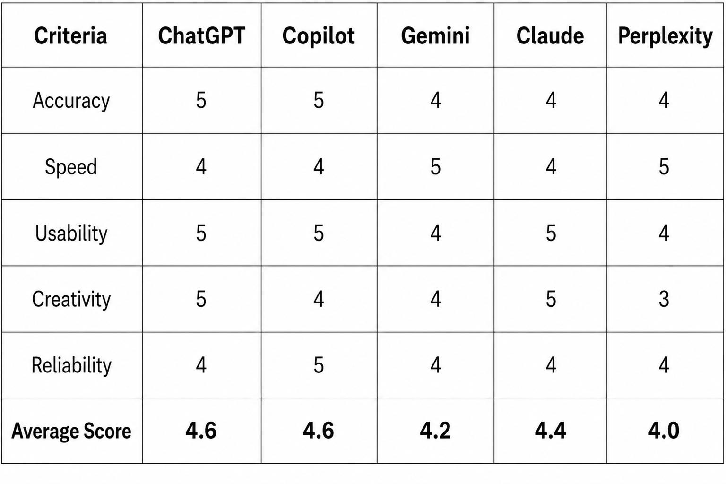

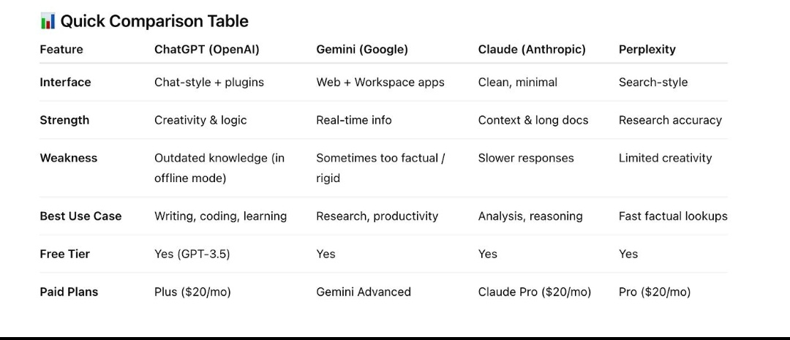

CONCLUSION:
- Best Tool for Coding: ChatGPT
- Best Tool for Research: Perplexity AI / Gemini
- Best Tool for Content Writing: Claude
- Best Tool for Presentations: Microsoft Copilot
- Overall Best AI Tool: ChatGPT & Microsoft Copilot (Tie)

